# Shell Script Assignment

1. Create a script named “myscript” in current directory to do the following.
2. display “hello user”
3. list files in current directory
4. name of logged in user
5. date

**vi myscript.sh**

**echo ‘hello user’**

**ls**

**echo “name of logged $USER”**

**date**

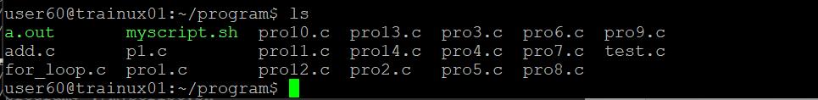

1. Add execute permission and Run the script from
2. current directory

**chmod +x myscript.sh**

1. Create a subdirectory named “test”

Mkdir test

1. Change to “test” directory. Run the script “myscript” [Hint: You will have to update PATH to include the directory containg script to run script from any location].

